Index.
- Integrating JavaScript and HTML in browsers.
- Run javascript with node.
- Node.

The purpose of the DI module is to create graphical user interfaces for desktop environments. This can be done with programming languages ​​like java oc # but it can also be done using web technologies to generate desktop applications. In the latter case we will use node, which allows us to run javascript directly without using a browser. This topic is an introduction to node and node projects.

1. Integrating JavaScript and HTML in browsers.

To embed the JavaScript code in our HTML, we need to use the <script> tag. The recommended place to put the tag is just before closing the </html> tag, so that some browsers can load and build the DOM before processing the JavaScript code, otherwise the browser will block rendering of the page until all JS code has been processed.
Inside the <script> tag:
<! DOCTYPE>
<html>

<head>
<title>JS example</title>
</head>

<body>
<p>Hello World!</p>
<script>
console.log("Hello World!");
</script>
</body>

</html>

In a separate file:
File: example1.html
<! DOCTYPE>
<html>

<head>
<title>JS example</title>
</head>

<body>
<p>Hello World!</p>
<scriptsrc="example1.js"> </script>
</body>

</html>

Example1.js file
console.log("Hello World!");

2. Run javascript with node.
Node.js is a server-side runtime environment built using Google Chrome's Javascript engine, called V8. What is done is to use externally the same execution engine that Google Chrome uses to compile and run Javascript in the browser: the V8 engine. This engine is responsible for compiling and executing the Javascript code, transforming it into faster code (machine code).
It is also responsible for placing the necessary elements in memory, removing unused elements from it (garbage collection), etc.
V8 is written in C ++, it is open-source and high-performance. It is used in the Google Chrome browser and "variants" such as Chromium (adaptation of Chrome to Linux systems), as well as in Node.js and other applications. We can run it on Windows (XP or later), Mac OS X (10.5 or later) and Linux systems (with IA-32, x64, ARM or MIPS processors).
In addition, being written in C ++ and being open source, we can extend the options of Javascript itself. As we have mentioned, initially Javascript was a language conceived to be executed in a browser. We couldn't read a local text file, for example. However, with Node.js an extra layer of functionality has been added to the base provided by V8, so that it is now possible to carry out these tasks, thanks to the fact that with C ++ we can access local files, or connect to a base of data. Specifically from node we have:

- Mechanisms to access the file system, which is particularly useful for reading text files, or uploading images to the server, to give two examples.
- Mechanisms to connect with databases.
- Communicate over the Internet (the ECMAScript standard does not have these elements for Javascript).
- Accept customer requests and send responses to those requests.

Node can be downloaded from the web:https://nodejs.org/es/

Visual Studio Code
It is a multilanguage code editor widely used with node:
https://code.visualstudio.com/download

Hello world in Node
We can execute javascrit files without the need of a browser, in the example we have created point 1, to execute this file, from the command line, write: node example1.js

3. Node projects.
NPM
npm is the default package management system for Node.js
Projects in Node
The usual thing when working with node is to have a folder that will contain the project. To start a project we will use npm:
- Create a folder in the location you want, give it a name without blank spaces.
- Then access the folder from your console or terminal and run the following command: npm init. The above command generates a custom package.json file for each node project.

Example of a project with node
We are going to create a project with node using the previous example example1.js. First we create a directory called example1 and copy the file example1.js:

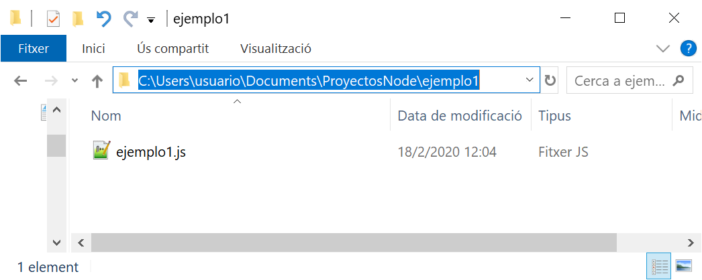

Open the folder with visual studio code by right-clicking on the example1 folder and selecting the option to open with code:
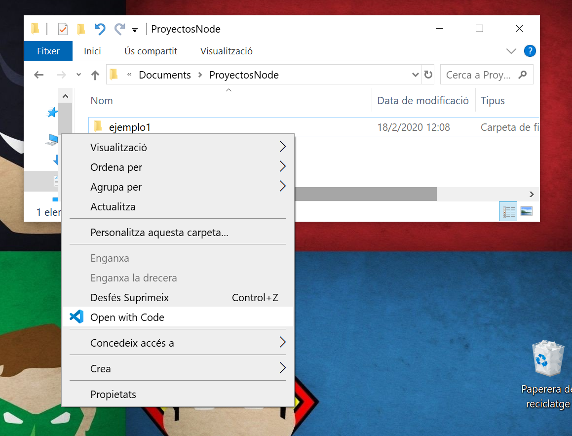

Visual studio code will open with the content of that folder:
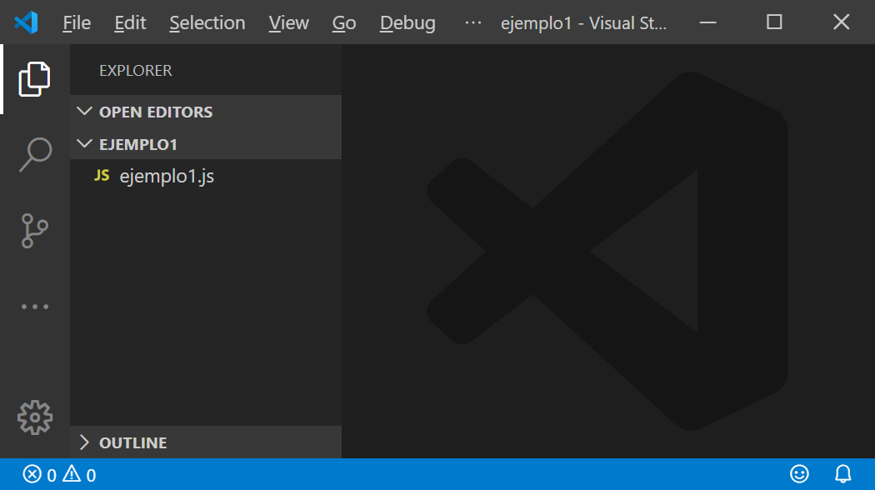
To run npm we can do it from the usual command line or using the code. To display it, do "CTRL + ñ":
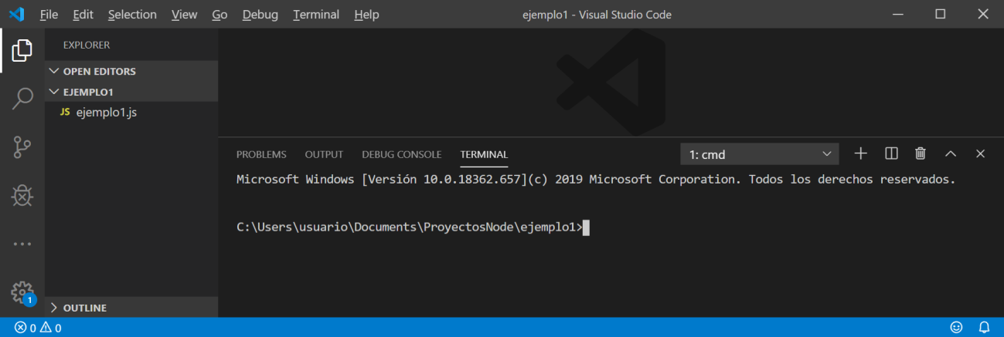

With the npm init command we will create the project, which involves generating a package.json file that defines our project. When executing npm init from within our project folder (in this case example1) we can leave all the default options by hitting enter:
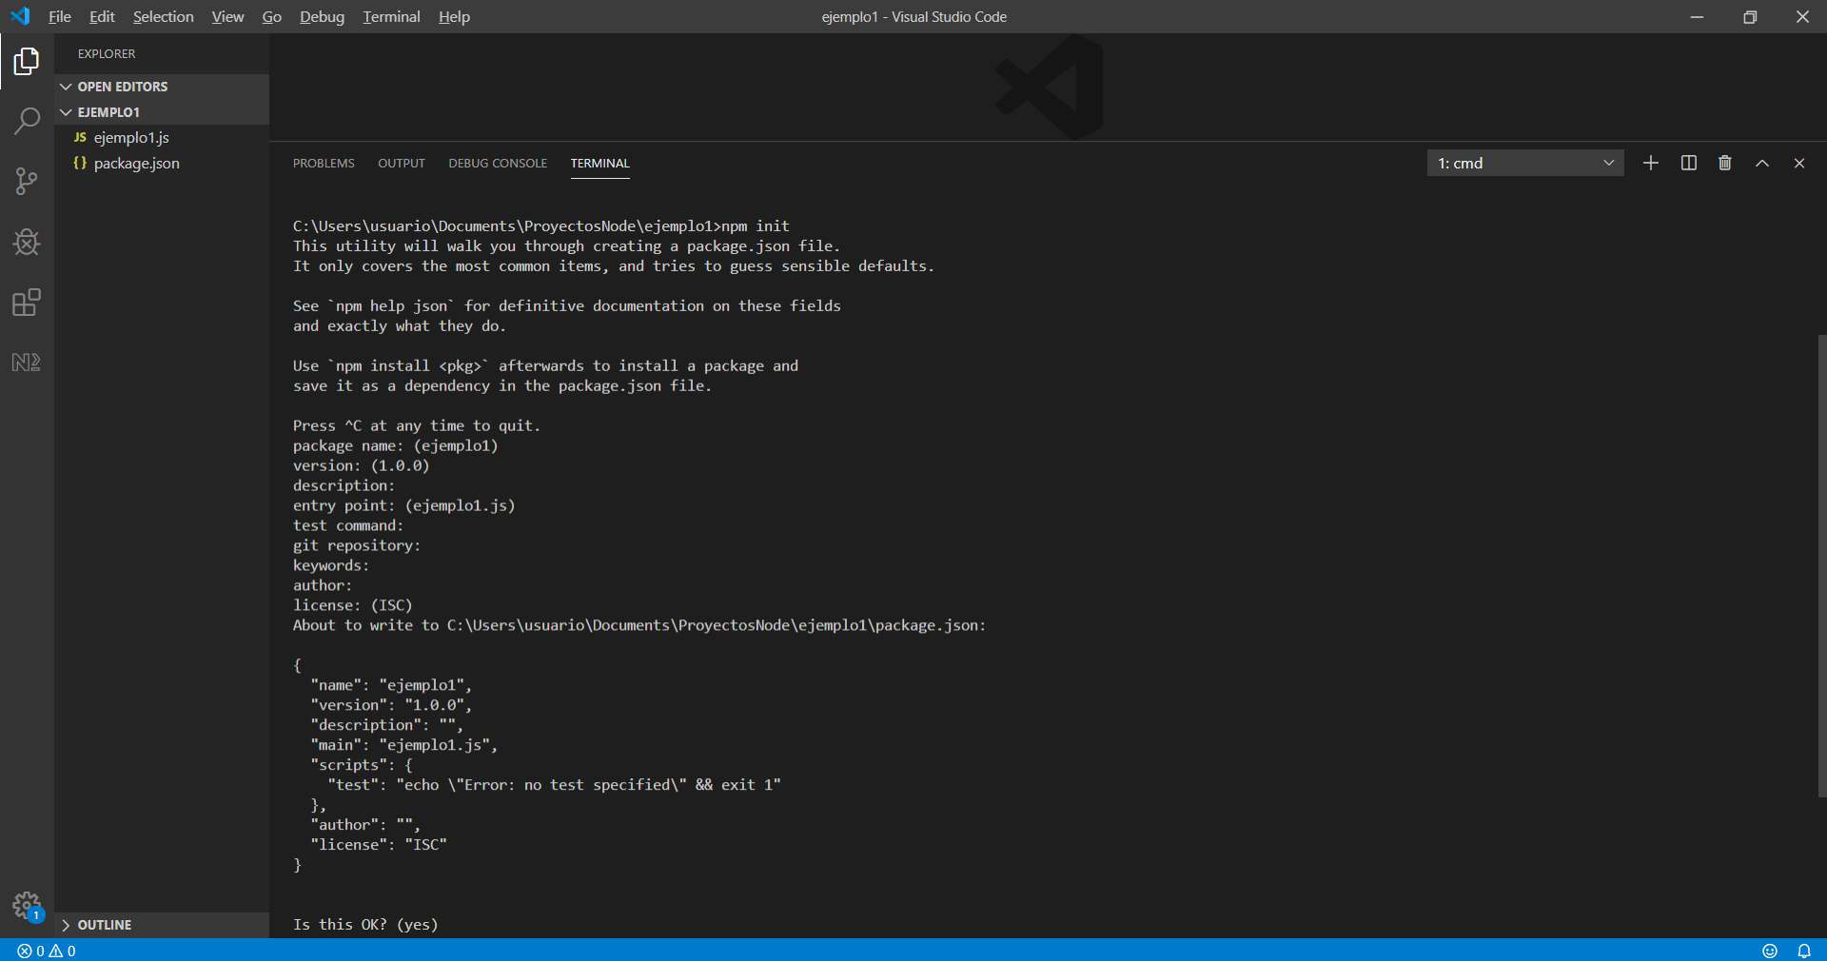
We are going to add a line to package.json to run the project using npm:
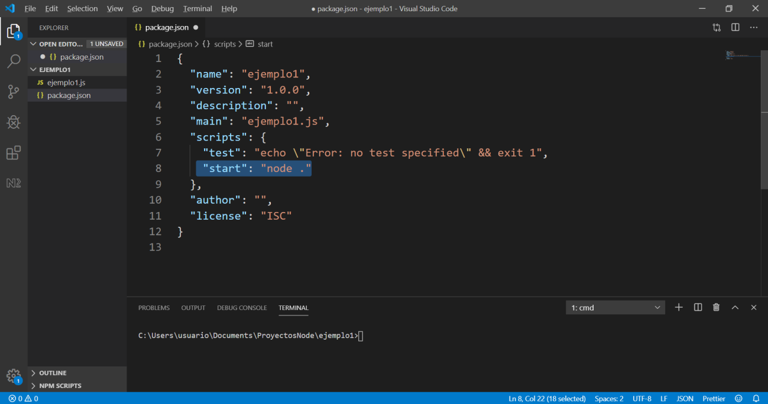
We save the contents of package.json, now we can run the project using npm start:
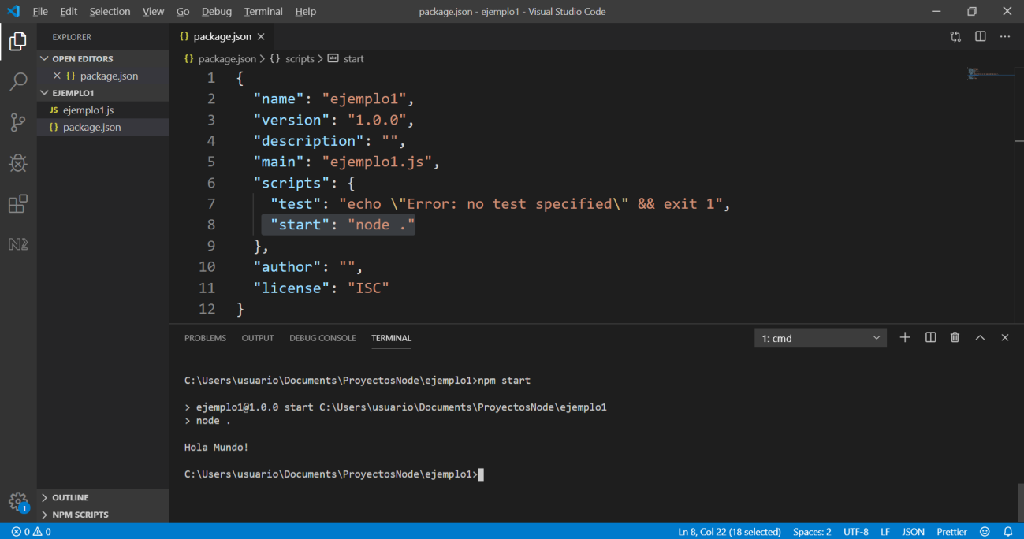

What npm start does is execute the command that we have put in the start line of the package.json, using as a javascript file the one specified in the main entry of package.json.

